**Arjumand Majid Bhat**

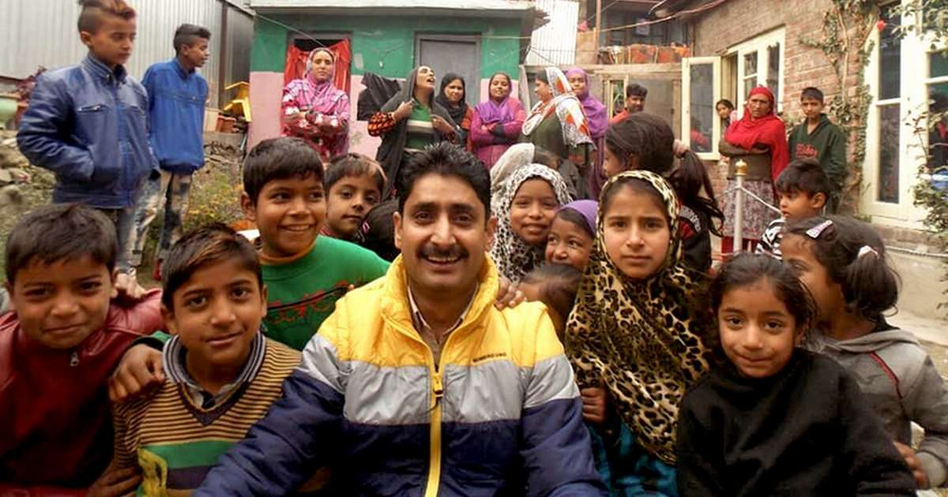

**About:** Arjumand Majid Bhat, popularly known as Raju Mistery , as everyone called him, was a 36-year-old man who had earned a name for himself in the past few years as a counselor for drug de-addiction in Baramulla town.Raju was a 36-year-old man who had earned a name for himself in the past few years as a counselor for drug de-addiction in Kashmir. Arjumand had started work as a drug de-addiction campaigner nearly nine years ago. He ran a center with the support of the Indian Army in Baramulla town. He struggled financially. His brother, a doctor, would consult patients at his shop, allowing Raju to earn a livelihood. He would also work as a small-time contractor with army, supplying them food for parties the officers hosted for their Kashmiri guests. Arjumand had recently intensified his campaign against the drug abuse in Baramulla, which many people, including police officials, believe was funded by the army. Some photos on his Facebook page also show him at a counseling session to drug addicts at an army camp.

**Murdered on:** 01 Apr 2019

**Attack details:** Arjumand Majid Bhat was seated on a revolving chair at his chemist shop when ‘unidentified gunmen’ shot five bullets at his head.

**Reason to him target:** Militants had published his name twice for supposedly being an informer.

**Occupation:** Arjumand Majeed, was a Chemist and ran a medical shop and a drug de-addiction center in Baramulla. He would organize seminars on drug de-addiction in Baramulla and was a familiar face with journalists.

**Belief:** Arjumand worked to wean away youth from drugs, many of who were lured to stone-pelting with the promise of drugs.

**Reaction of local population:** Raju was an angel who pulled them out from the deadly world of drugs. Many of them cried over his body at his house. But Raju is now gone. And we are all aware who the “unidentified gunmen who killed him.

We don’t know whether Raju was an informer, a man of the army or of militants. But what we do know is that he had come to the rescue of many people and also changed many lives for good. For them, he will remain a martyr.

**Rumor of any involvement:** Militants had published his name twice for being an informer Baramulla Senior Superintendent of Police Abdul Qayoom said, “But he was not one. Anyone who helps the youth or goes to an army camp is not an informer.

**Link:** bhat <https://www.firstpost.com/india/arjumand-majid-bhat-shot-dead-by-unidentified-gunmen-was-a-de-addiction-campaigner-who-helped-many-youth-6364991.html>

